29884772

Kekgethilwe Moloi

Assignment1

Question 4 number 1

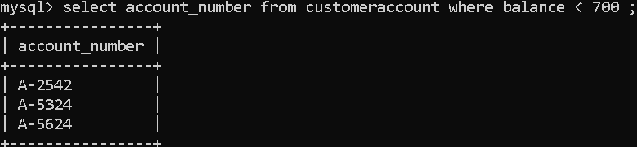

Question 4 number 2

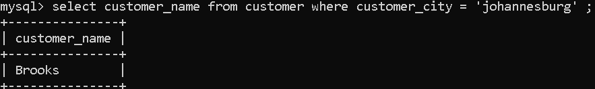

Question 4 number 3

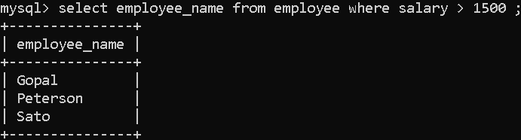

Question 4 number 4

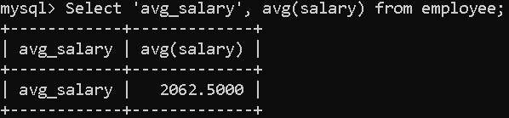

Question 4 number 5

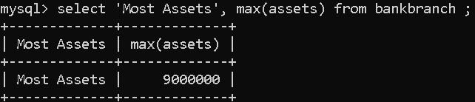

Question 5 number 1

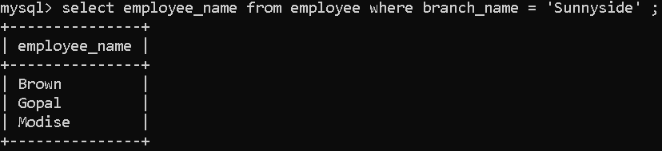

Question 5 number 2

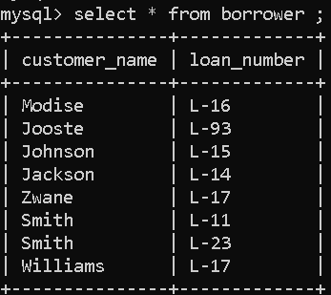

Question 5 number 3



Question 5 number 4

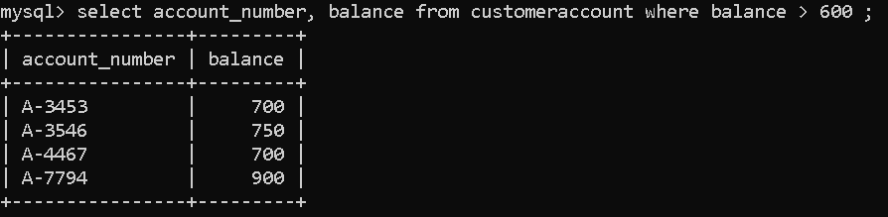

Question 5 number 5

